Silhouette metric for img015001.jpg is: 0.6046932653650584

Davies Bouldin metric for img015001.jpg is: 0.42607149611367334

Calinski Harabasz metric for img015001.jpg is: 352219.2052059999

ID 0: (1711, 695)

ID 1: (134, 606)

ID 2: (56, 721)

ID 3: (1543, 649)

ID 4: (99, 368)

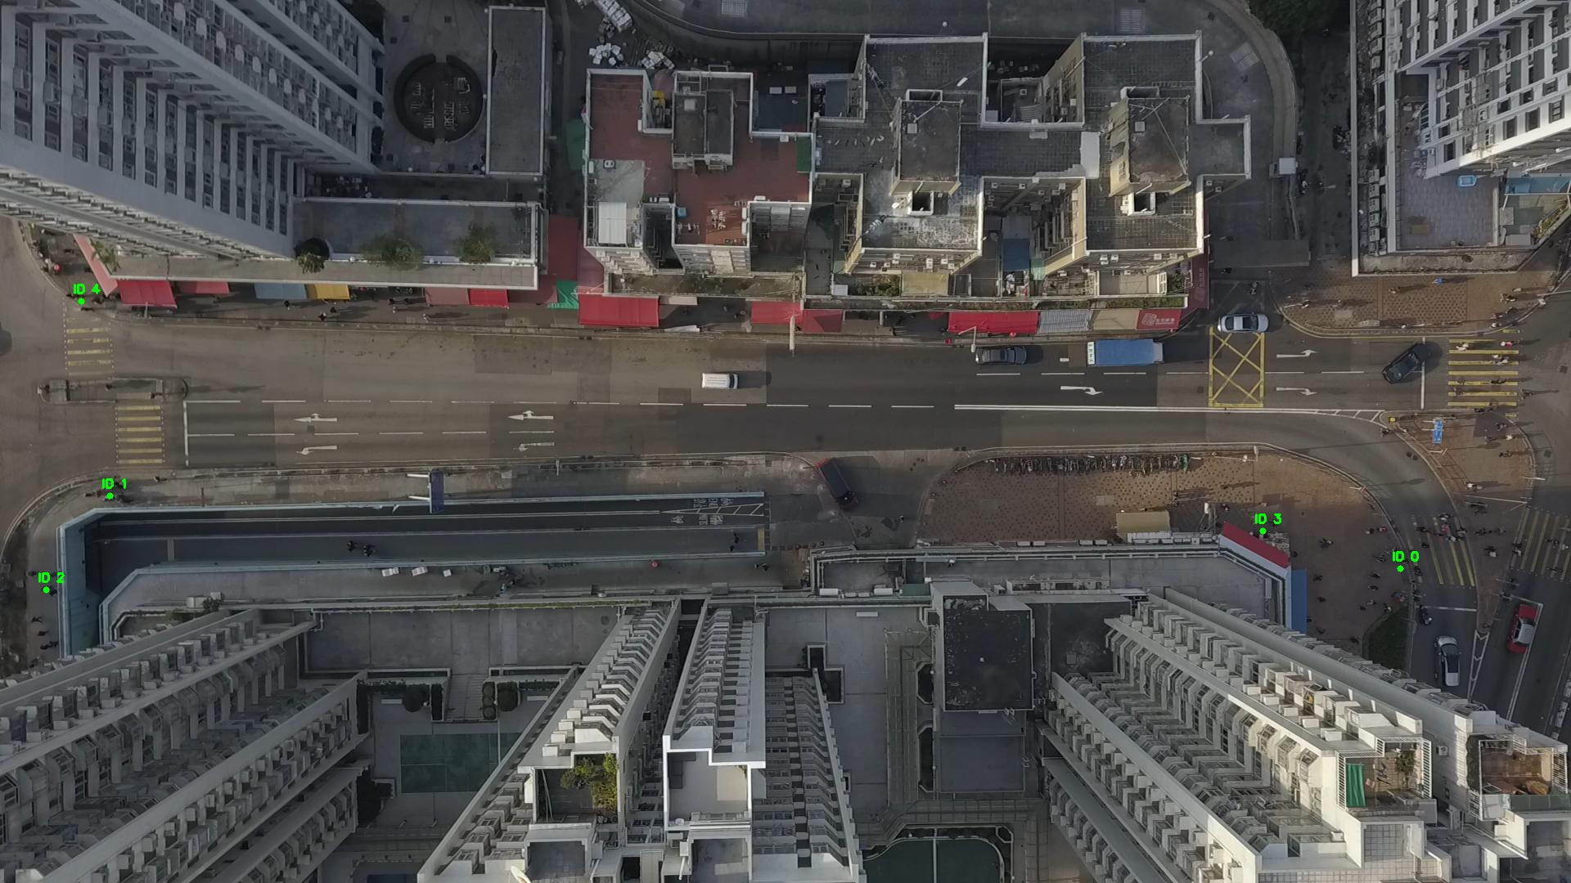

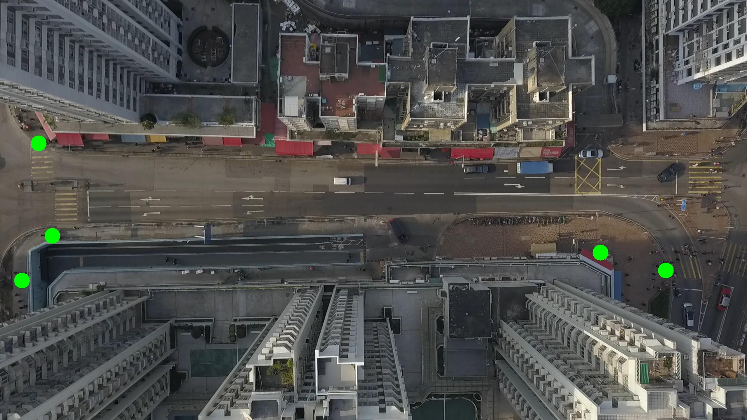

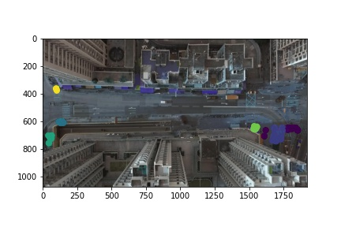

Silhouette metric for img015002.jpg is: 0.573881353360968

Davies Bouldin metric for img015002.jpg is: 0.5897816145323075

Calinski Harabasz metric for img015002.jpg is: 342427.8557669745

ID 0: (1711, 689)

ID 1: (132, 606)

ID 2: (52, 741)

ID 3: (1543, 648)

ID 4: (99, 368)

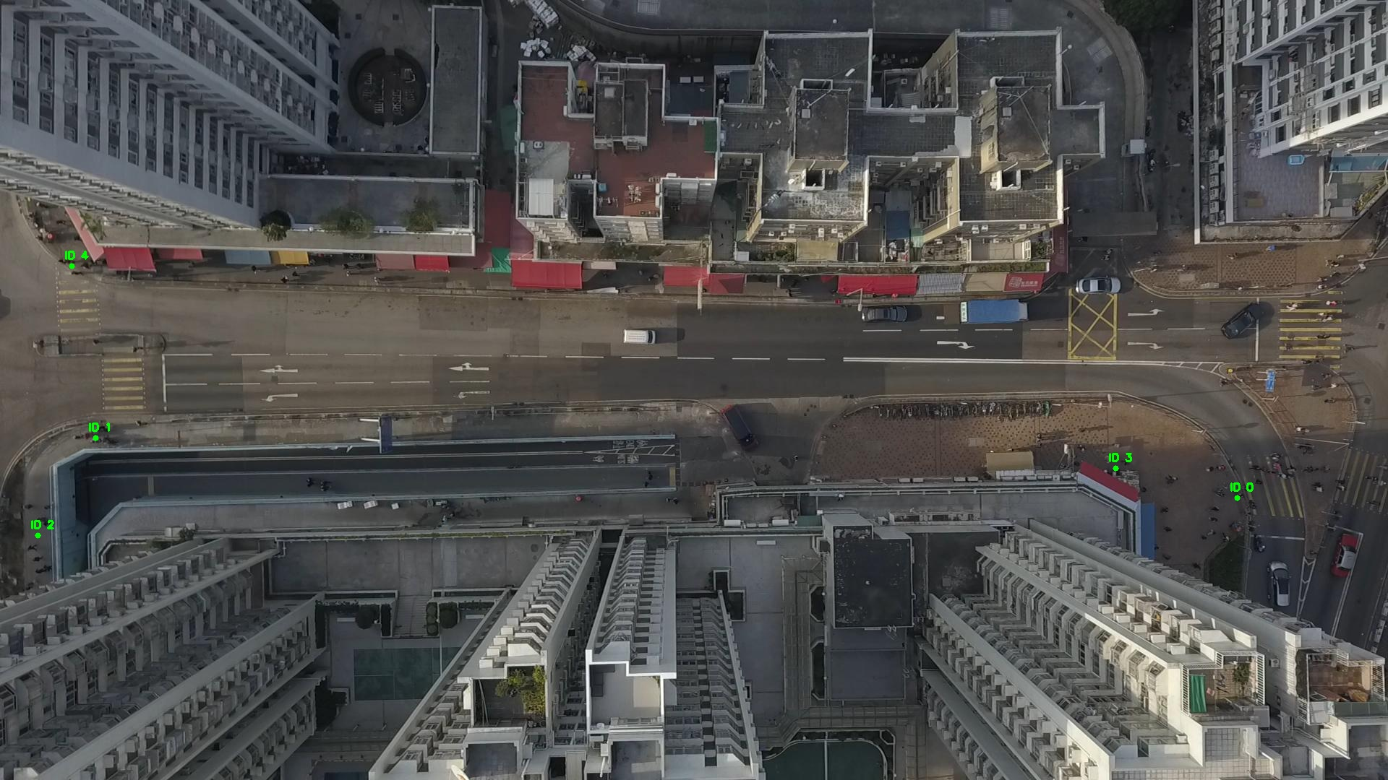

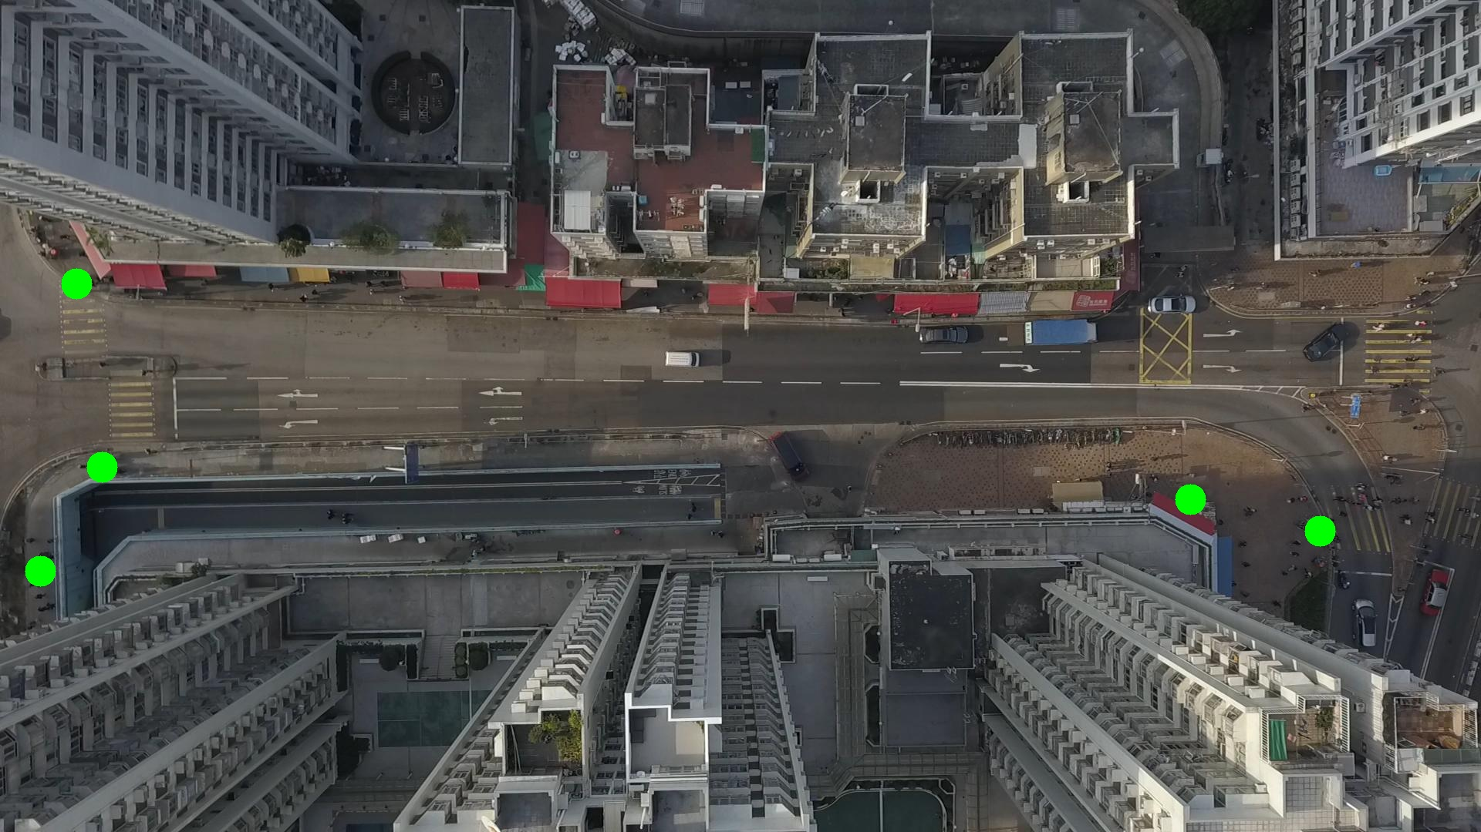

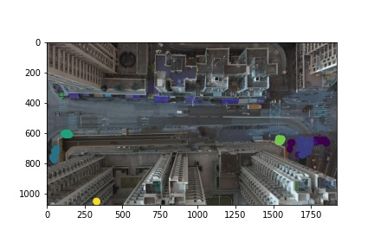

Silhouette metric for img015003.jpg is: 0.6003915949528805

Davies Bouldin metric for img015003.jpg is: 0.35572669761788395

Calinski Harabasz metric for img015003.jpg is: 400470.7379493933

ID 0: (1713, 688)

ID 1: (131, 606)

ID 2: (52, 732)

ID 3: (1565, 659)

ID 4: (99, 368)

ID 5: (406, 379)

ID 6: (331, 1054)

ID 7: (1530, 355)

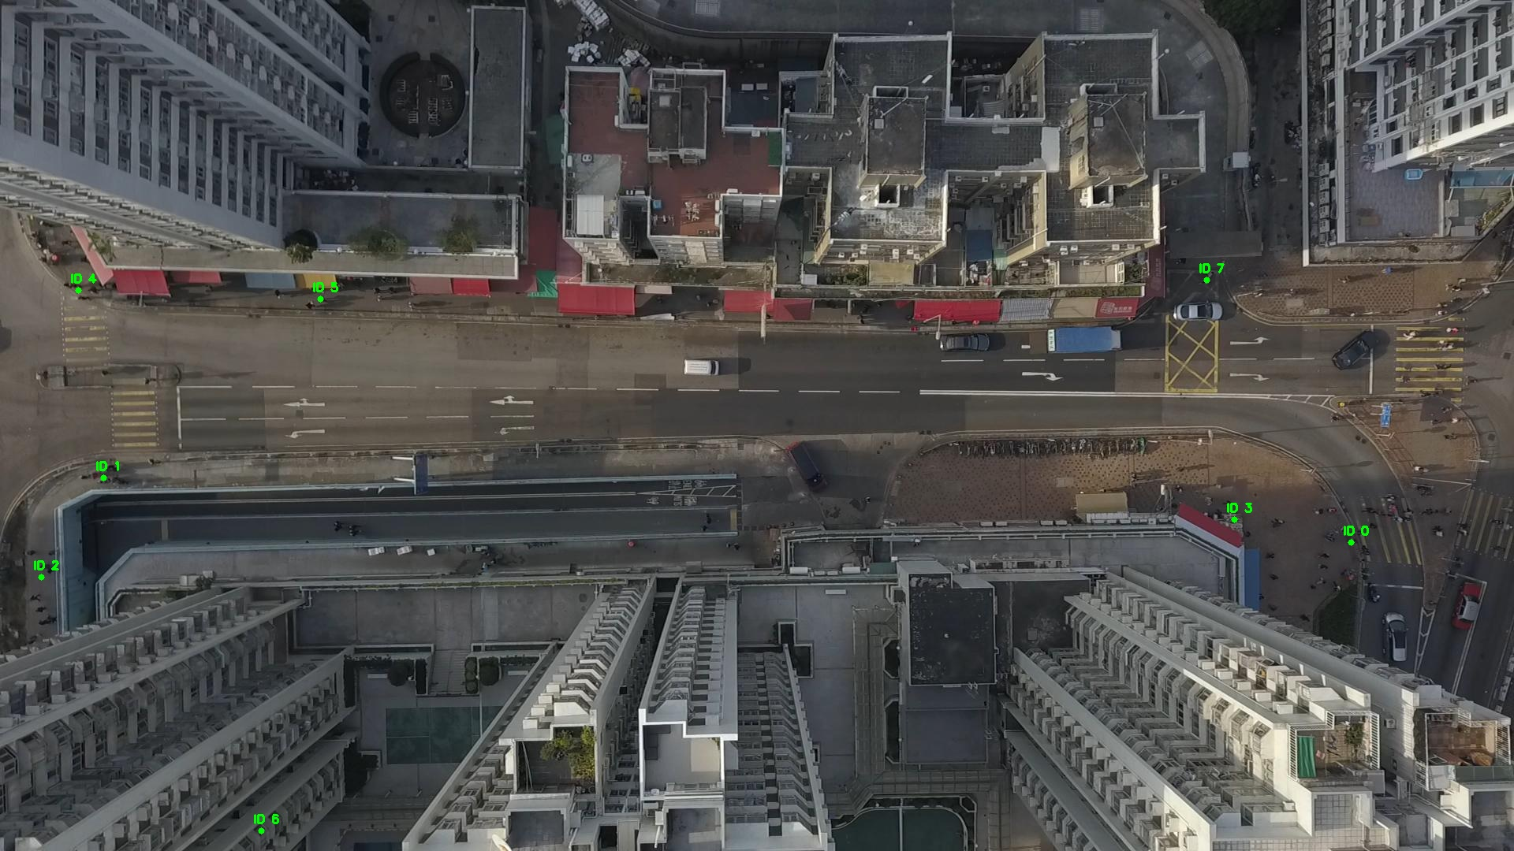

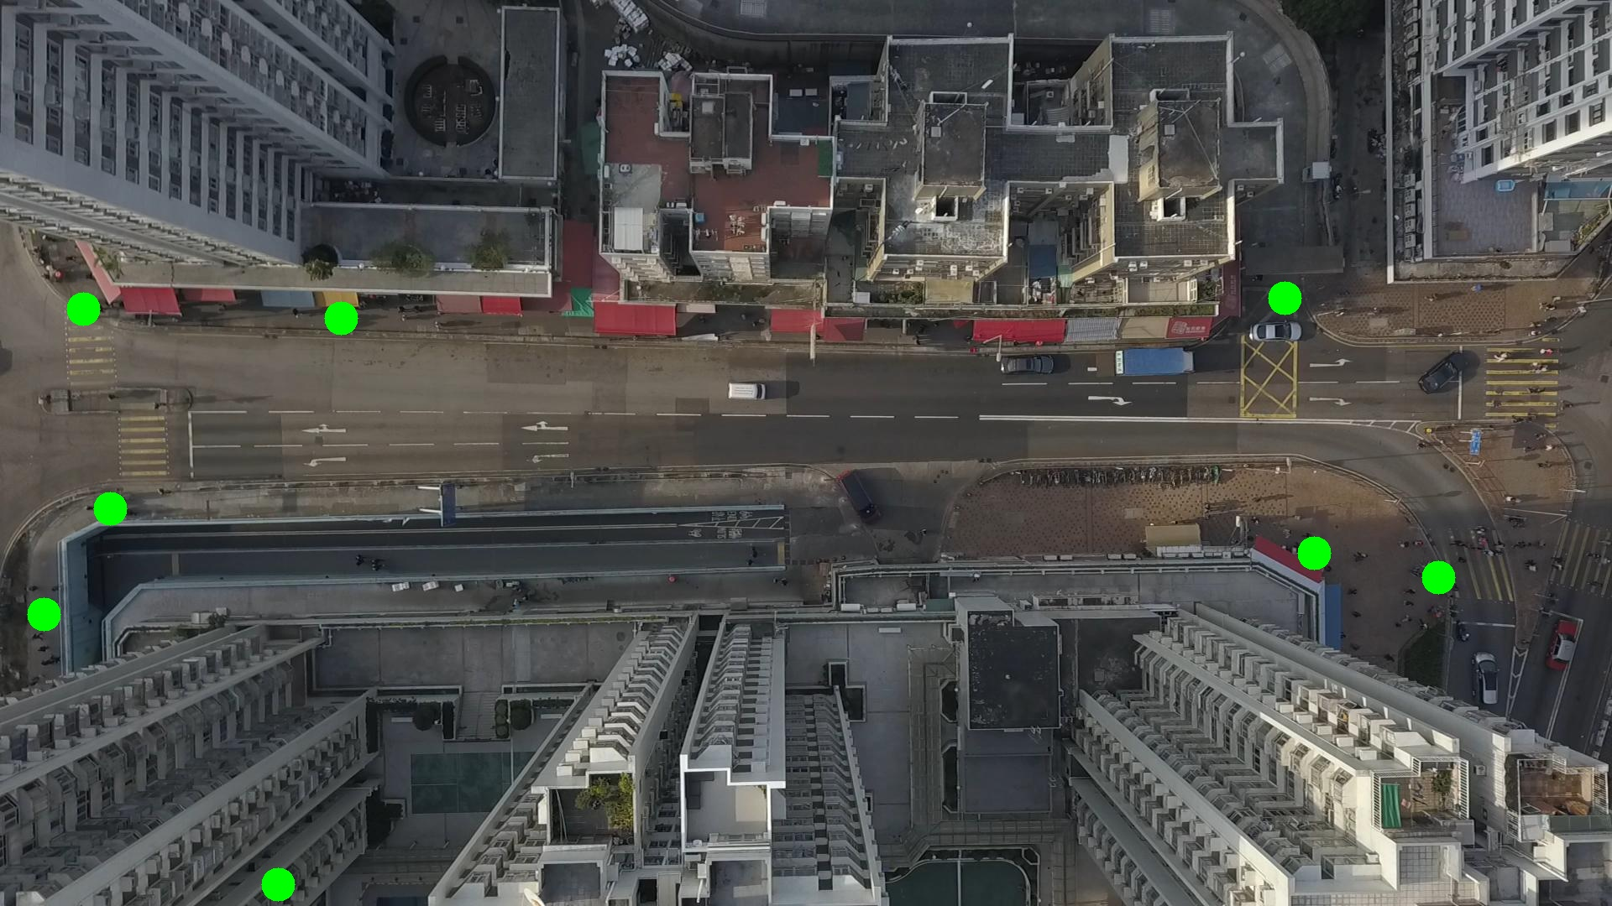

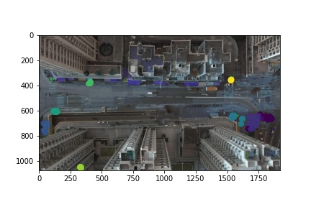

Silhouette metric for img015004.jpg is: 0.6637496971590754

Davies Bouldin metric for img015004.jpg is: 0.4171304939080247

Calinski Harabasz metric for img015004.jpg is: 361146.24010727106

ID 0: (1738, 664)

ID 1: (130, 605)

ID 2: (50, 727)

ID 3: (1574, 661)

ID 4: (102, 368)

ID 5: (409, 377)

ID 6: (332, 1054)

ID 7: (1529, 356)

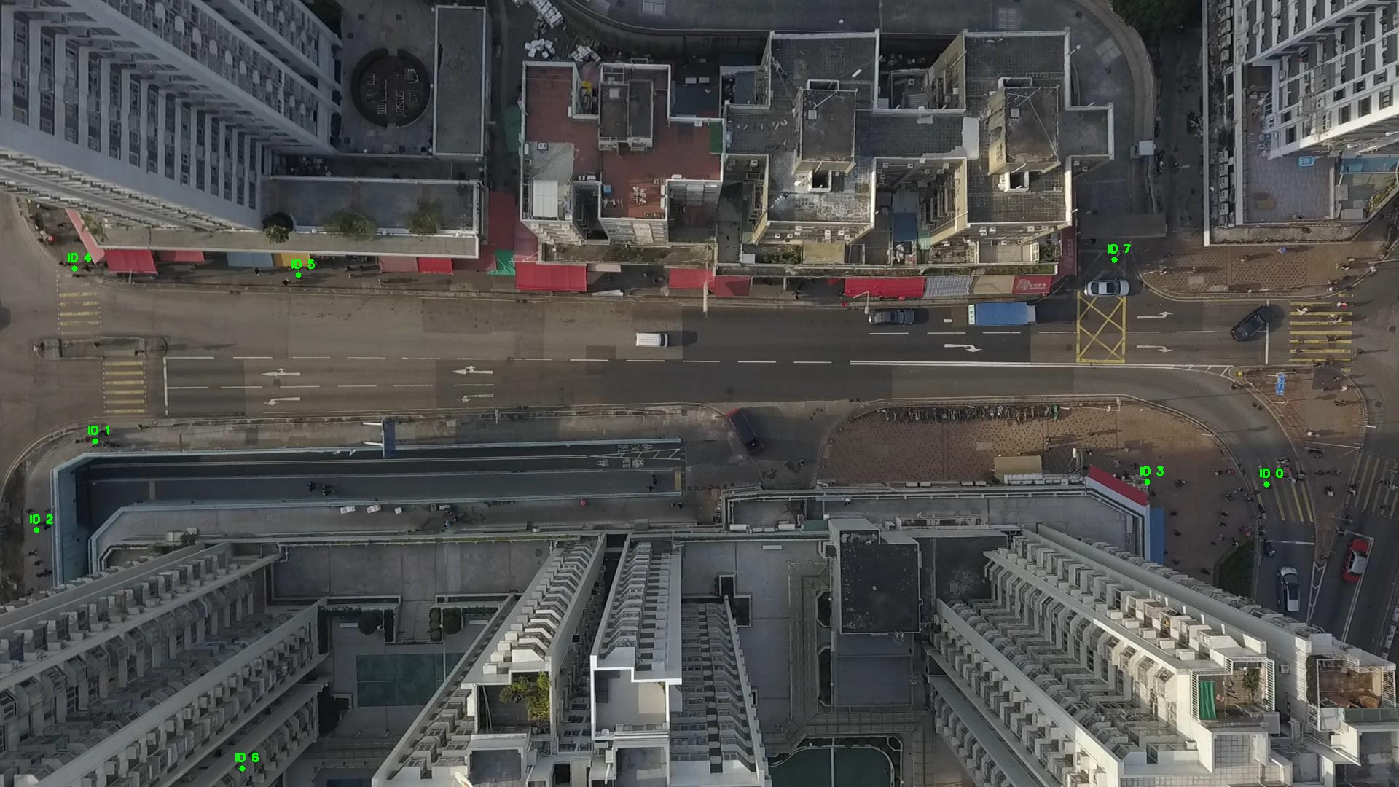

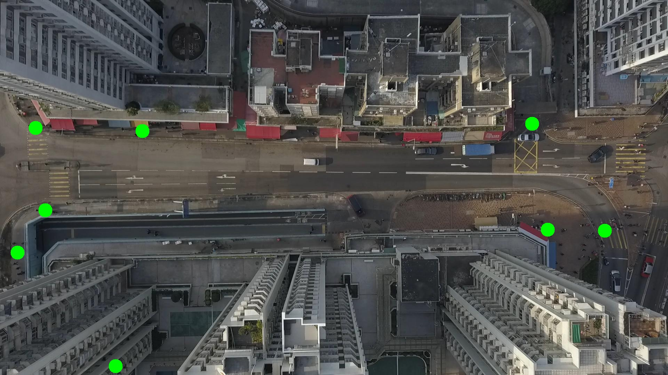

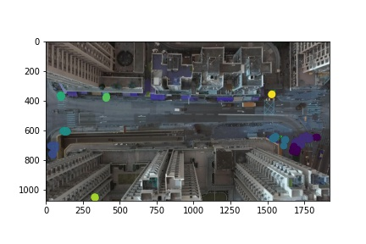

Silhouette metric for img015005.jpg is: 0.5803314269687174

Davies Bouldin metric for img015005.jpg is: 0.9591641642351001

Calinski Harabasz metric for img015005.jpg is: 229863.63926715252

ID 0: (1735, 669)

ID 1: (130, 606)

ID 2: (53, 730)

ID 3: (1570, 659)

ID 4: (105, 370)

ID 5: (409, 378)

ID 6: (331, 1053)

ID 7: (1529, 355)

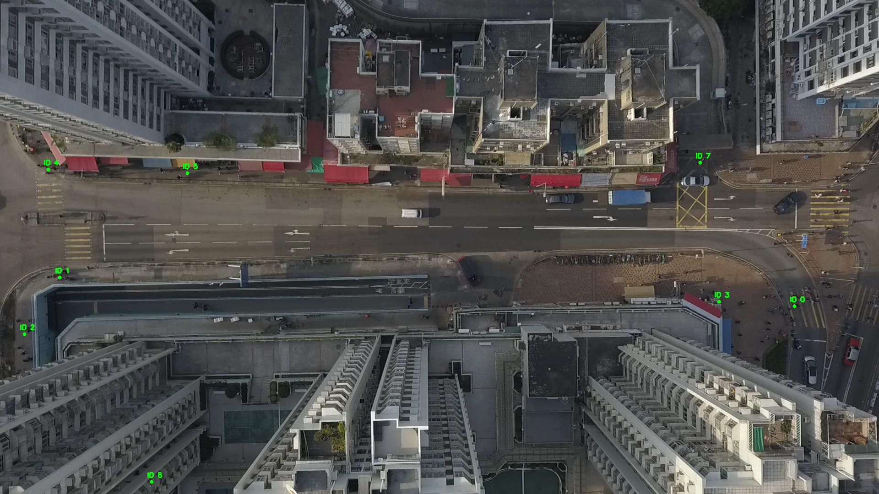

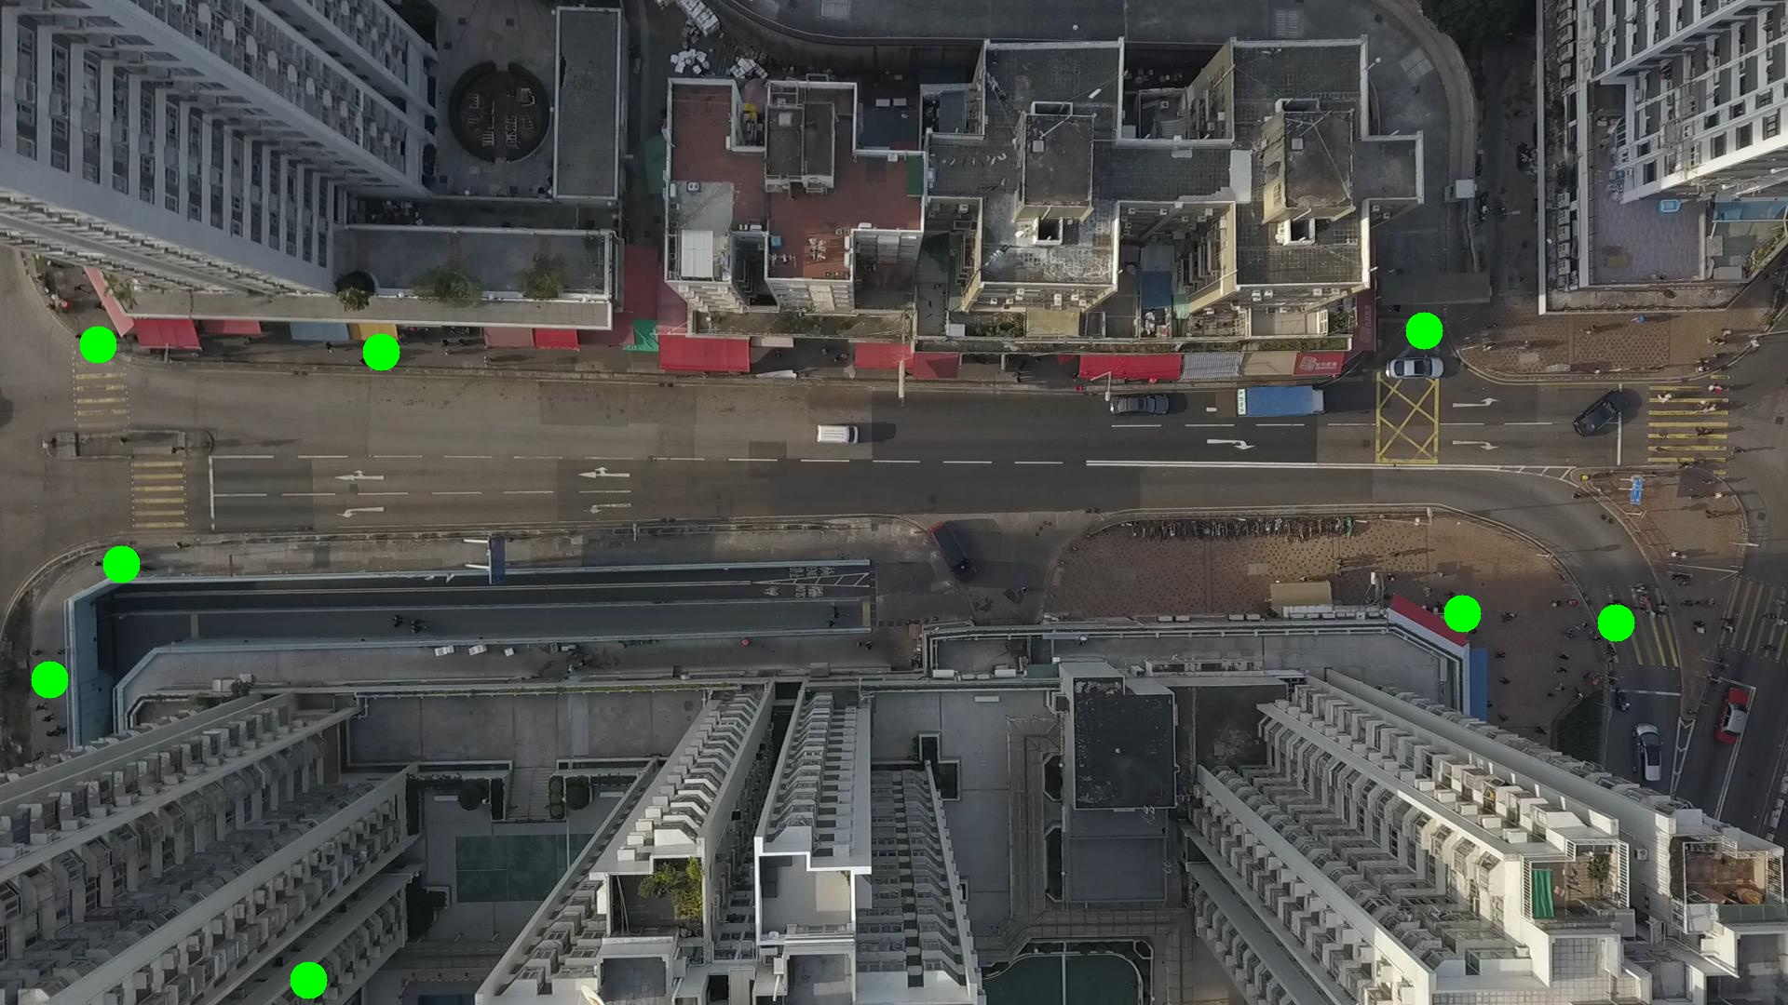

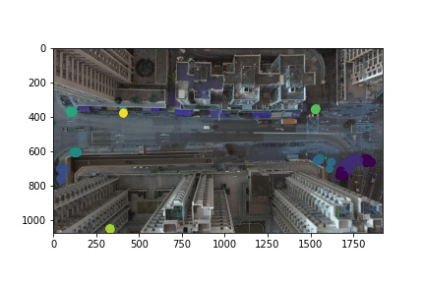

Silhouette metric for img015006.jpg is: 0.6235628887940566

Davies Bouldin metric for img015006.jpg is: 0.30682780650342534

Calinski Harabasz metric for img015006.jpg is: 423566.86474340403

ID 0: (1709, 695)

ID 1: (130, 606)

ID 2: (56, 741)

ID 3: (1568, 661)

ID 4: (105, 369)

ID 5: (410, 381)

ID 6: (331, 1053)

ID 7: (1529, 355)

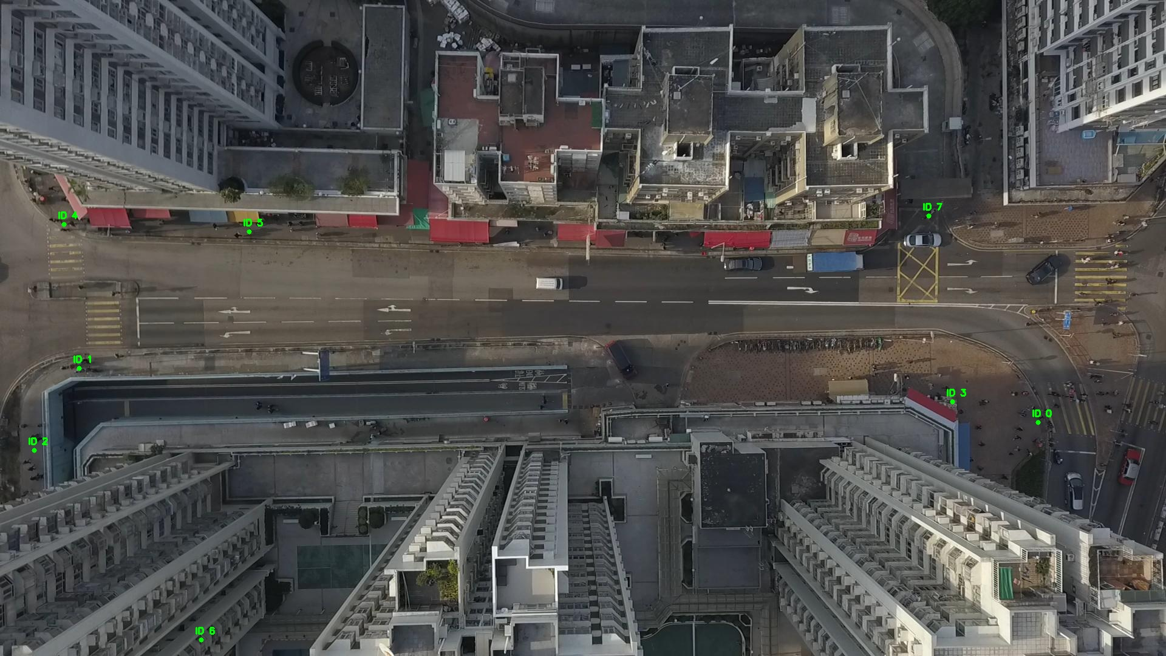

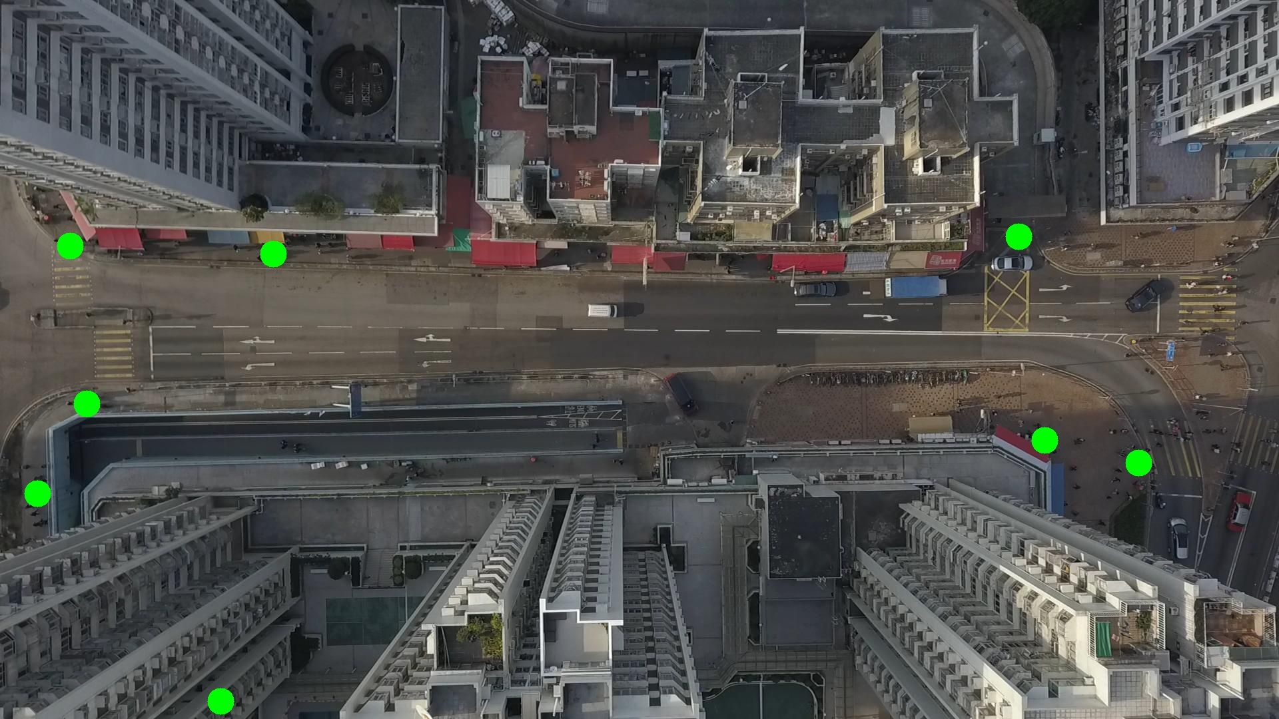

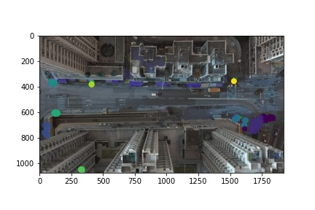

Silhouette metric for img015007.jpg is: 0.6330565281391238

Davies Bouldin metric for img015007.jpg is: 0.3031618805179611

Calinski Harabasz metric for img015007.jpg is: 426929.98250353016

ID 0: (1706, 690)

ID 1: (129, 607)

ID 2: (57, 743)

ID 3: (1545, 651)

ID 4: (104, 369)

ID 5: (410, 379)

ID 6: (332, 1052)

ID 7: (1529, 355)

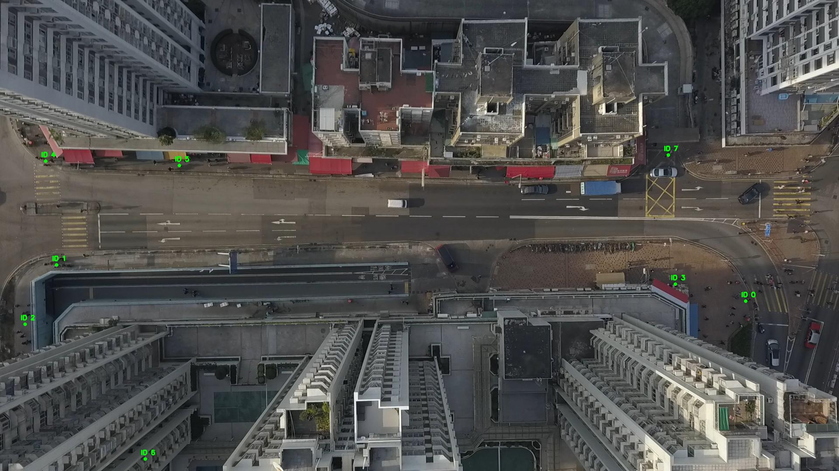

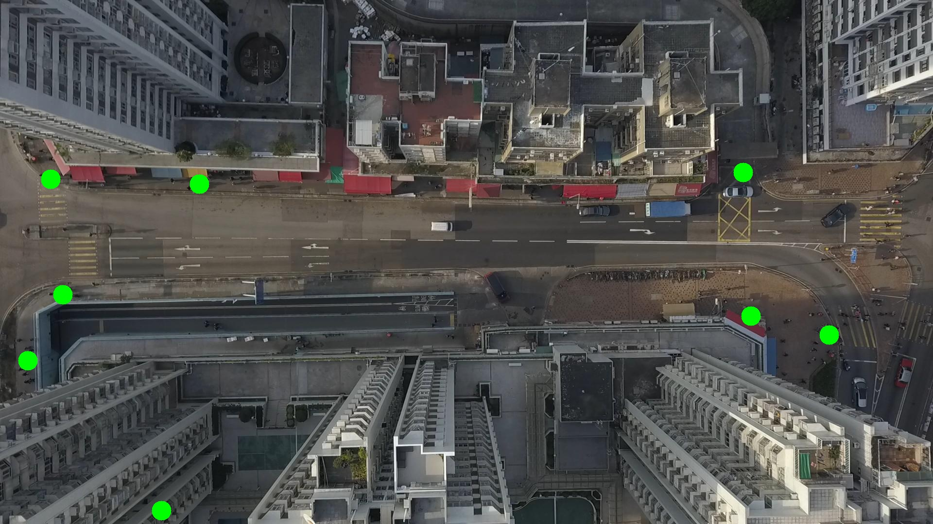

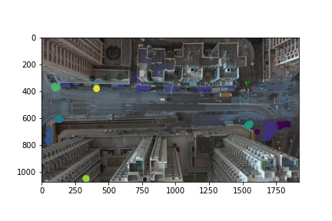

Silhouette metric for img015008.jpg is: 0.5958570402463408

Davies Bouldin metric for img015008.jpg is: 0.3532368007723409

Calinski Harabasz metric for img015008.jpg is: 340823.46098784904

ID 0: (1701, 691)

ID 1: (130, 606)

ID 2: (54, 733)

ID 3: (1545, 650)

ID 4: (105, 371)

ID 5: (410, 380)

ID 6: (331, 1052)

ID 7: (1527, 356)

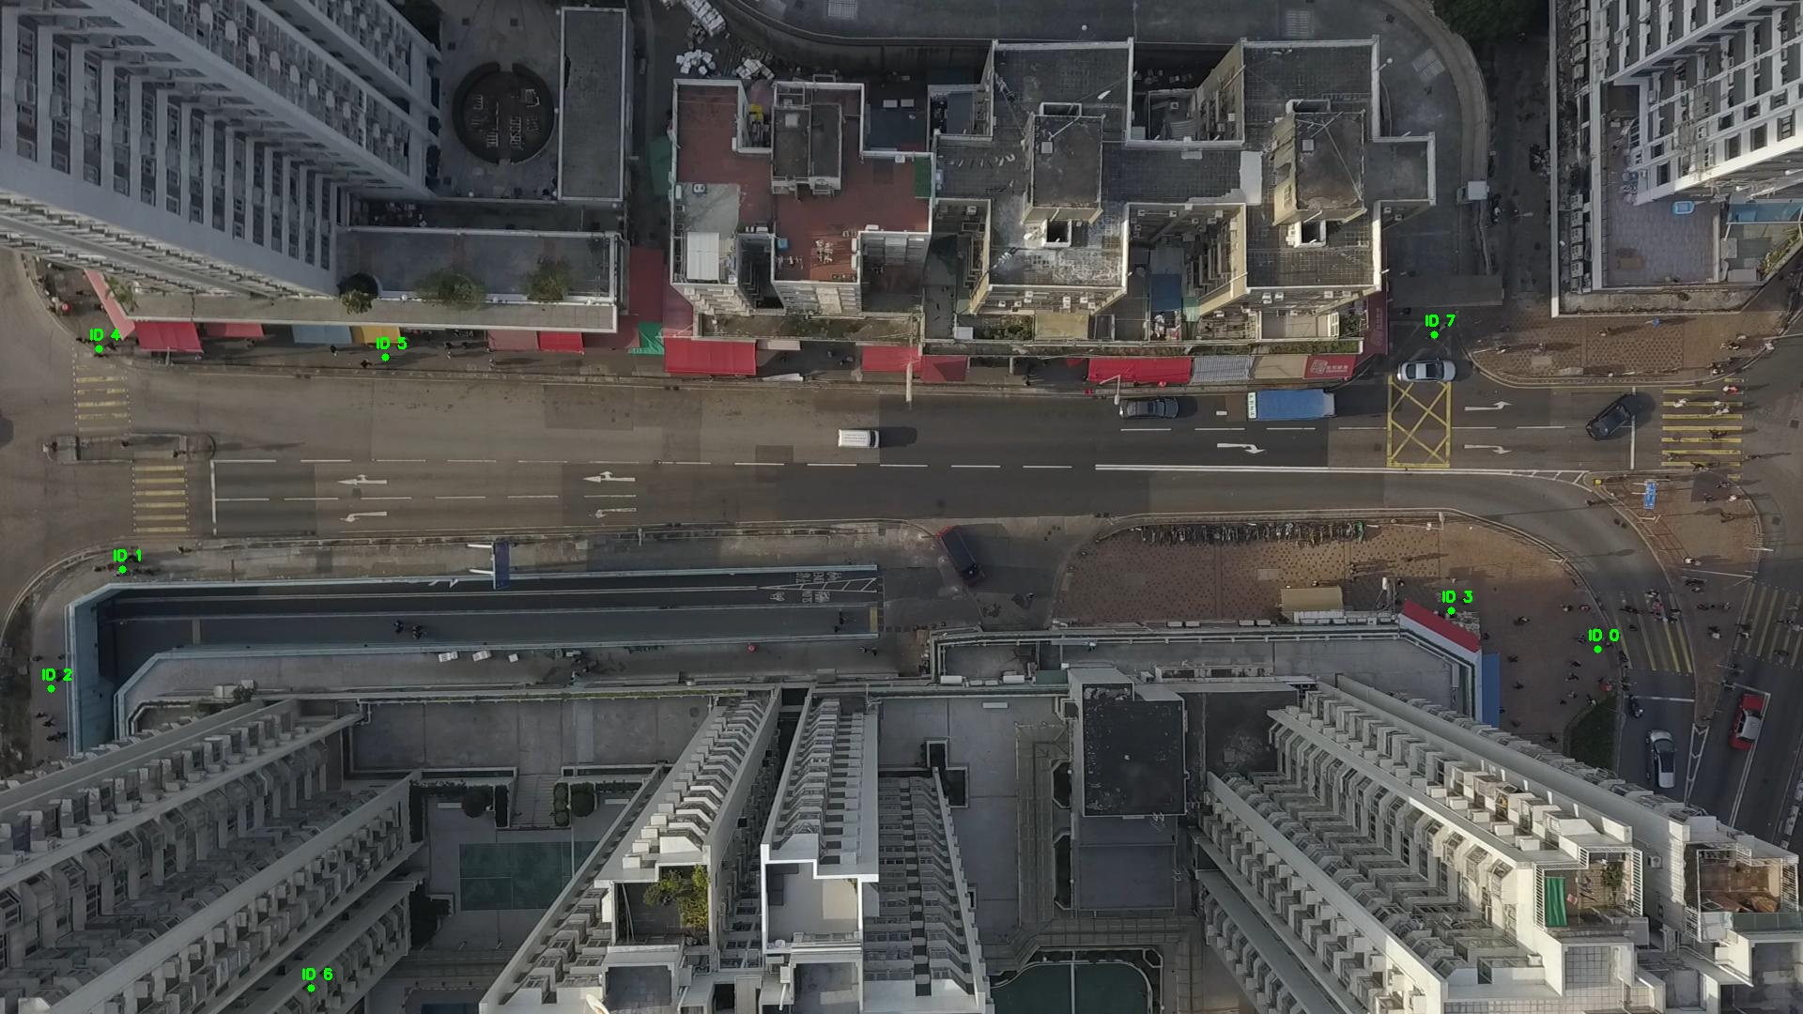

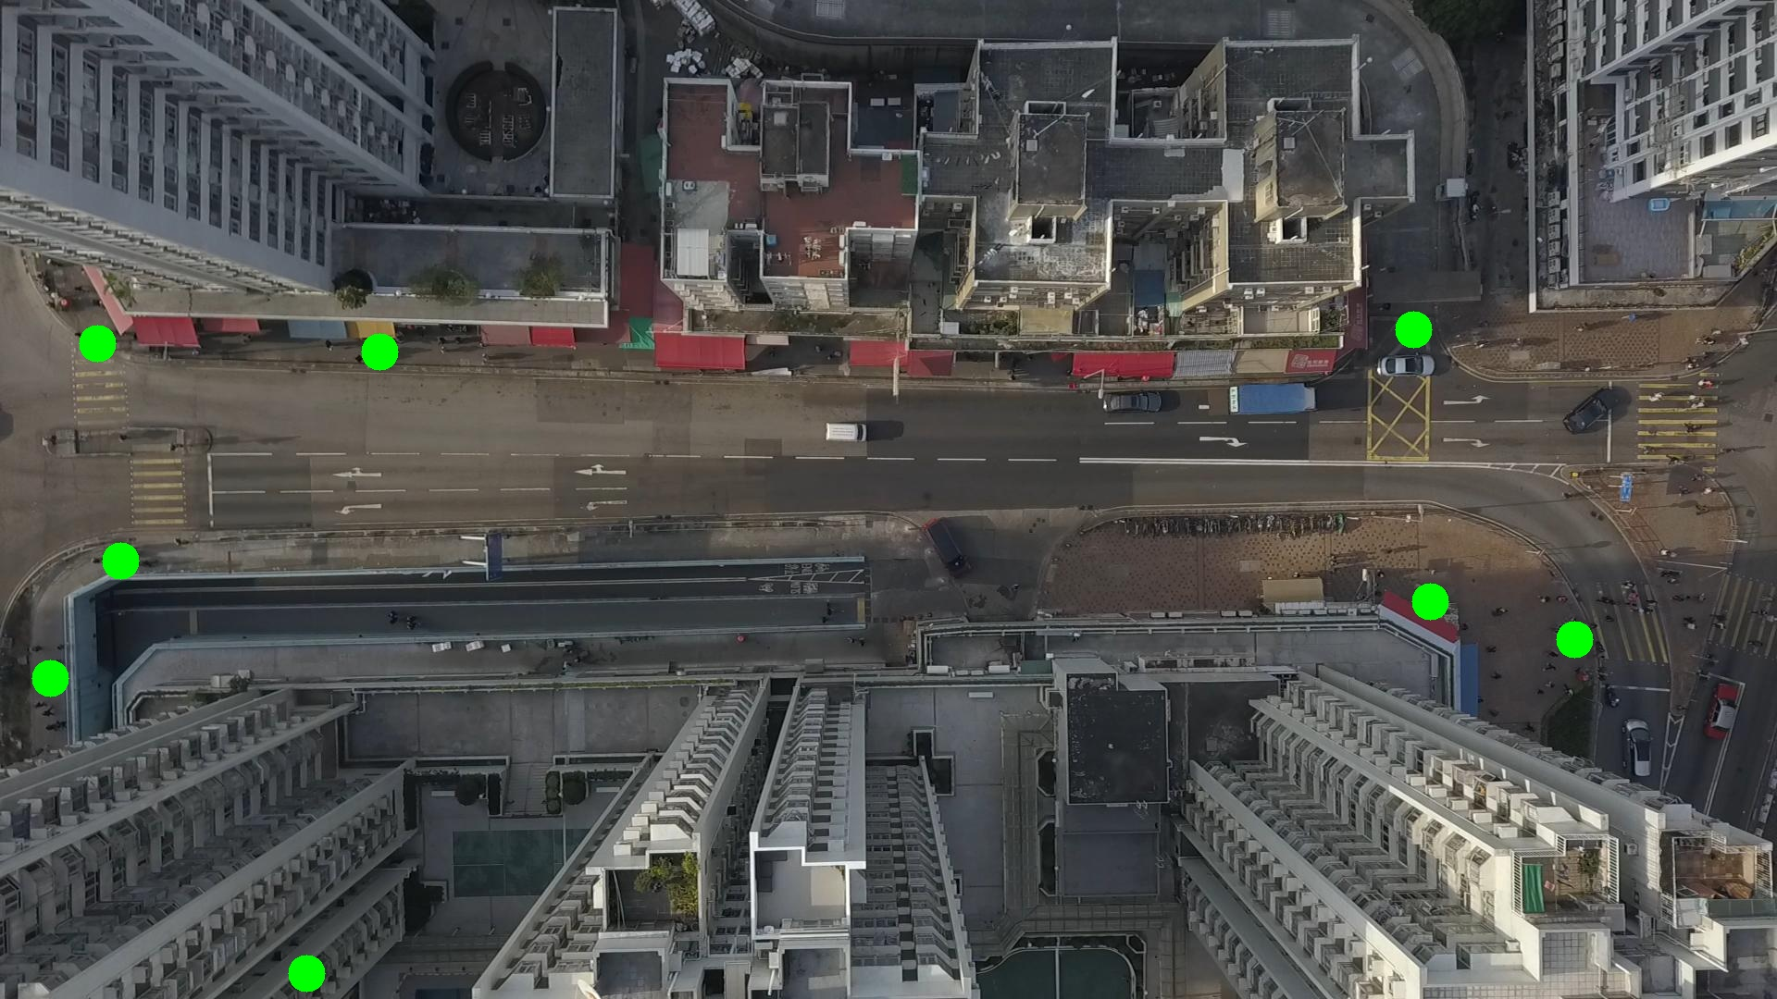

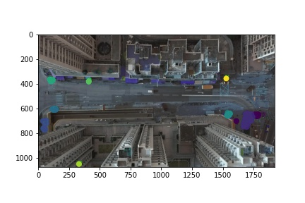

Silhouette metric for img015009.jpg is: 0.5702360018060615

Davies Bouldin metric for img015009.jpg is: 0.62326102114902

Calinski Harabasz metric for img015009.jpg is: 253168.51667740557

ID 0: (1721, 664)

ID 1: (132, 609)

ID 2: (54, 731)

ID 3: (1544, 651)

ID 4: (101, 373)

ID 5: (417, 376)

ID 6: (332, 1052)

ID 7: (1527, 356)

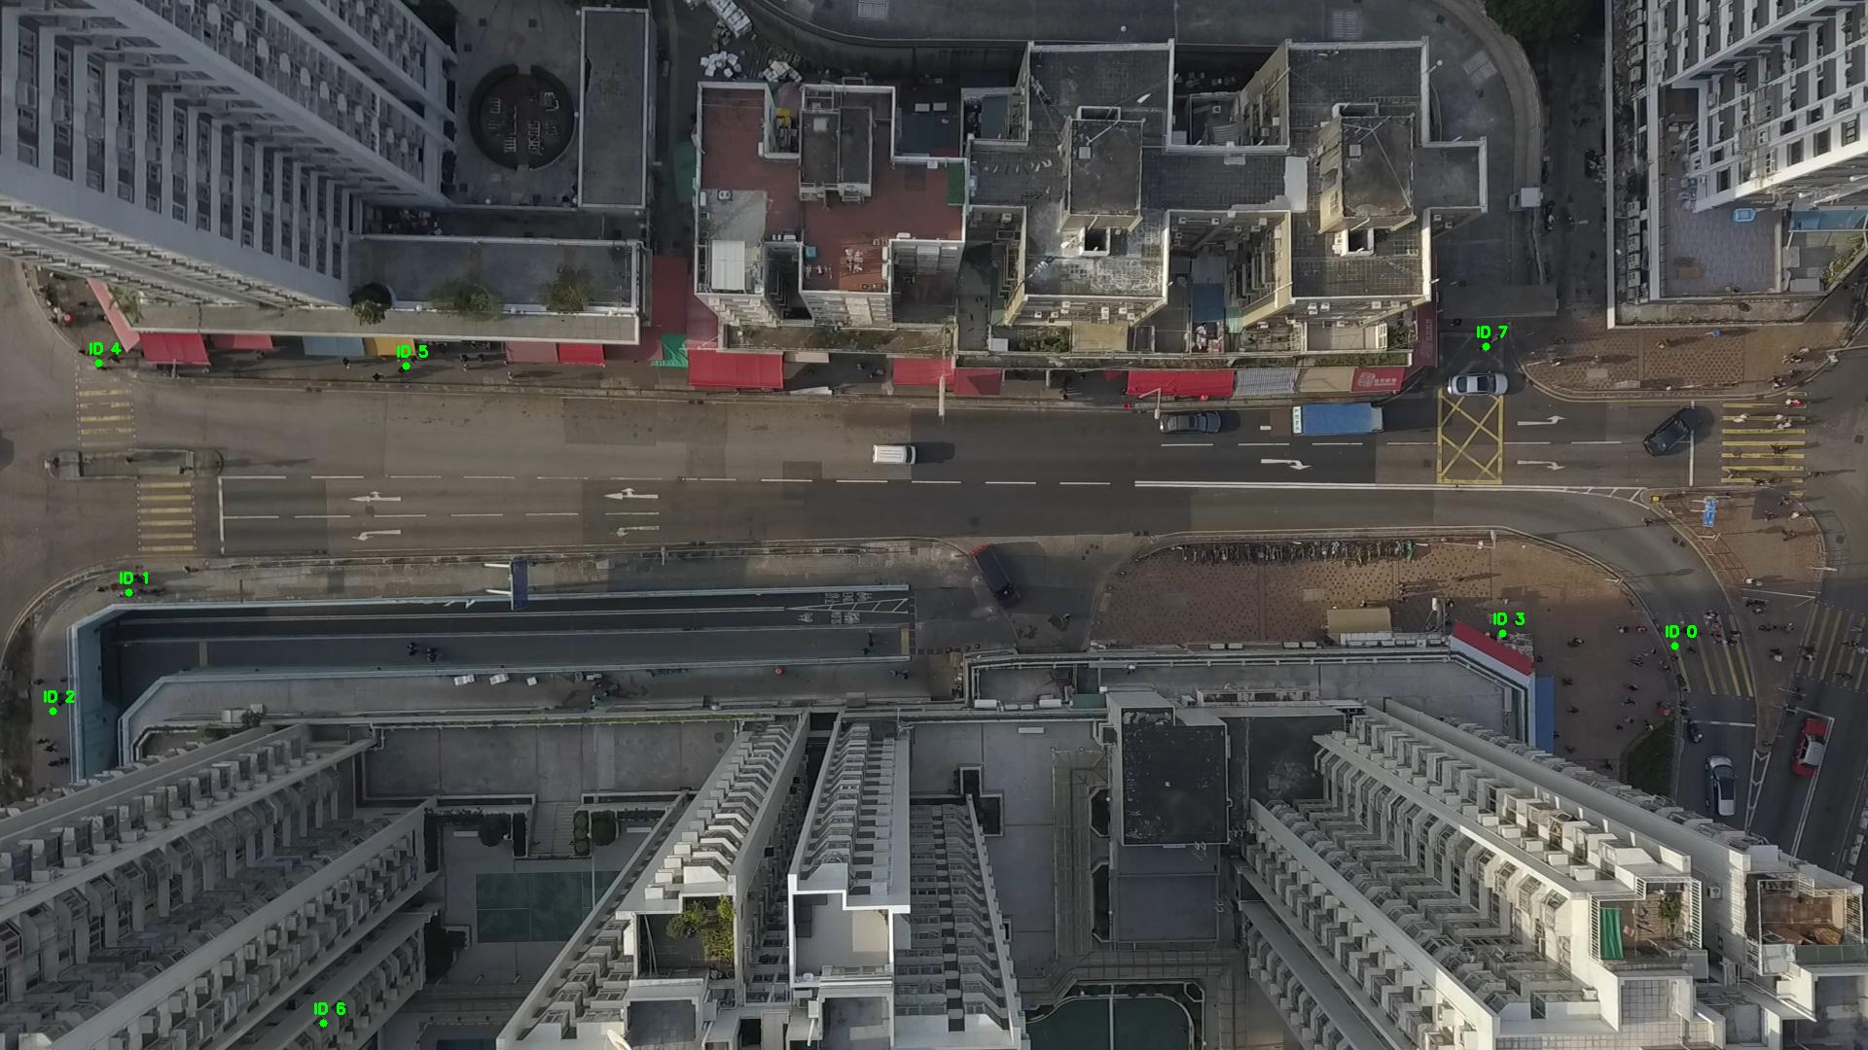

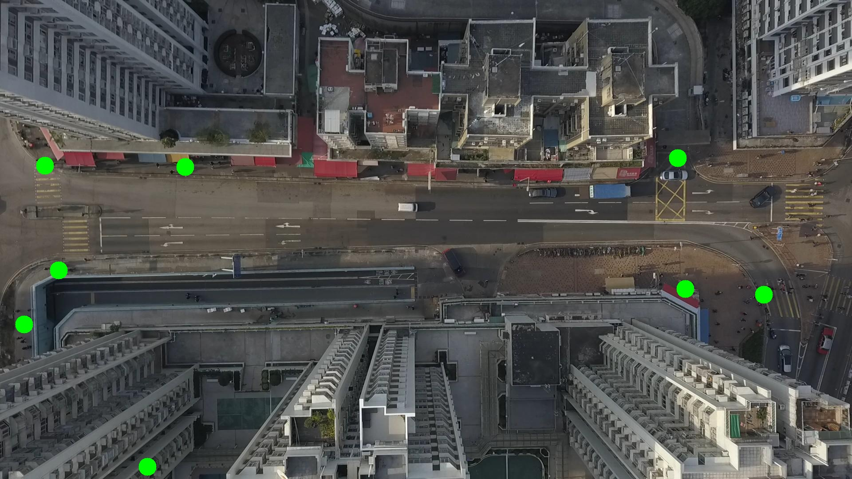

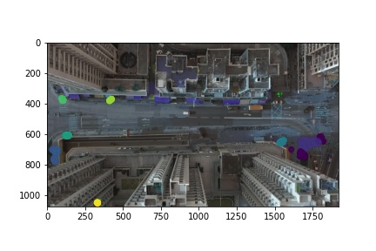

Silhouette metric for img015010.jpg is: 0.5314473261934158

Davies Bouldin metric for img015010.jpg is: 0.9440922634908512

Calinski Harabasz metric for img015010.jpg is: 199228.1554317196

ID 0: (1728, 663)

ID 1: (134, 608)

ID 2: (52, 732)

ID 3: (1568, 659)

ID 4: (102, 373)

ID 5: (422, 373)

ID 6: (332, 1052)

ID 7: (1527, 356)

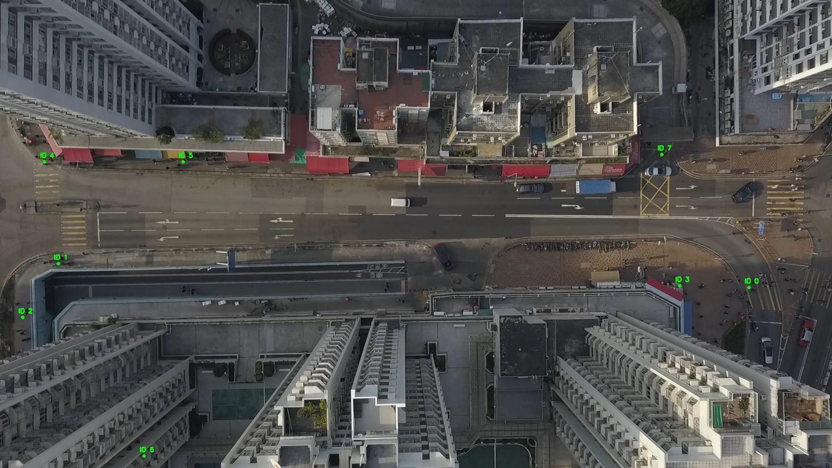

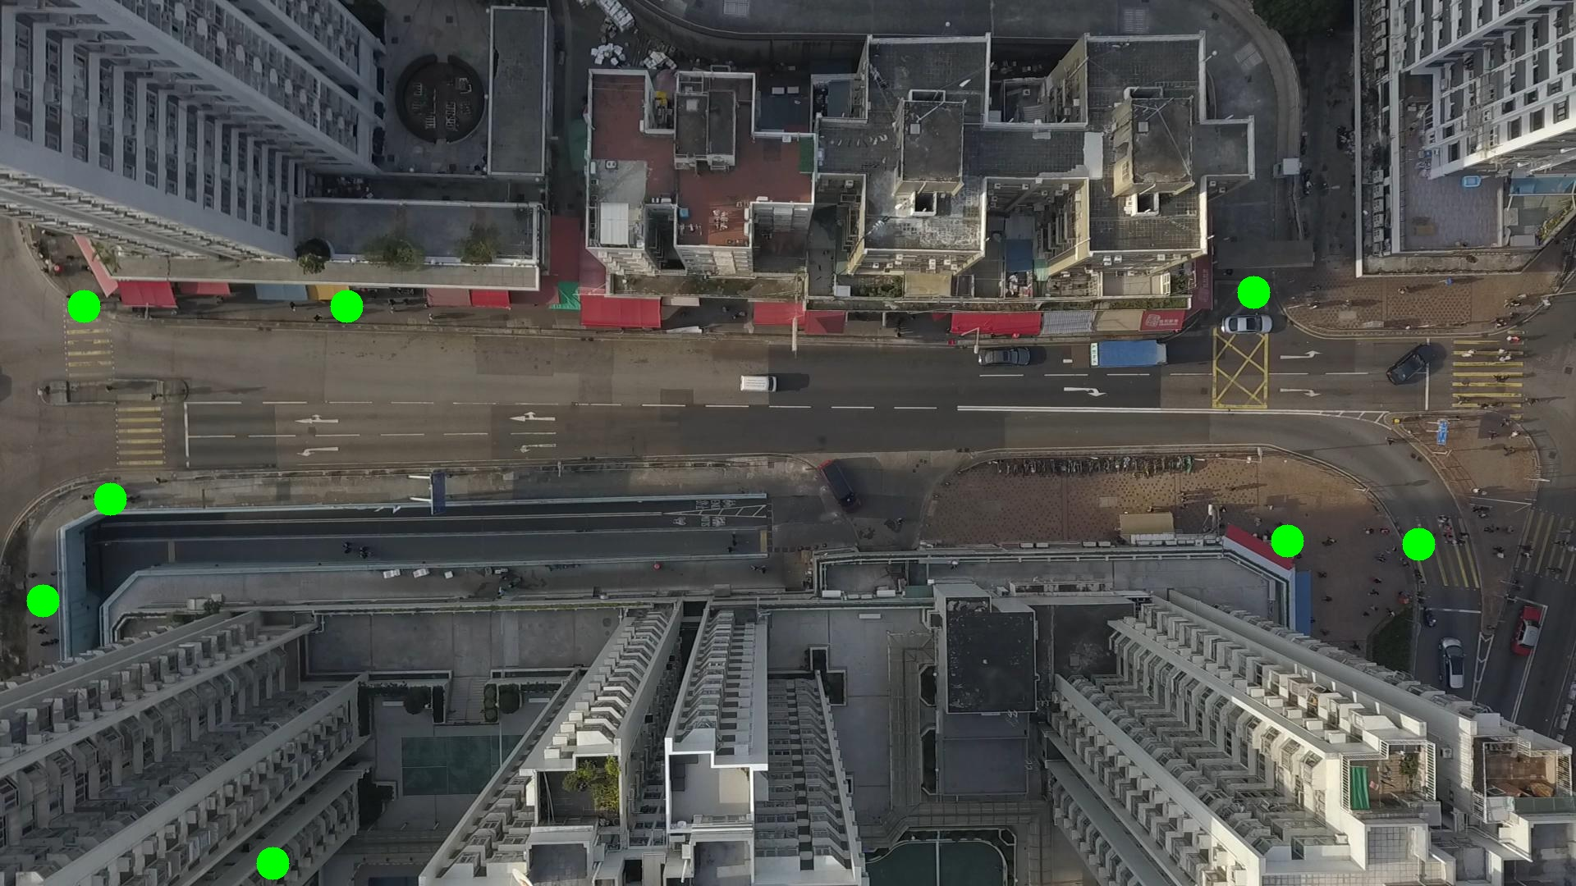

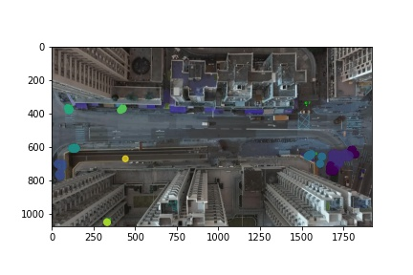

Silhouette metric for img015011.jpg is: 0.5544797623428215

Davies Bouldin metric for img015011.jpg is: 0.7902182602148186

Calinski Harabasz metric for img015011.jpg is: 279969.6173136291

ID 0: (1725, 667)

ID 1: (133, 608)

ID 2: (50, 735)

ID 3: (1576, 659)

ID 4: (104, 373)

ID 5: (425, 371)

ID 6: (332, 1052)

ID 7: (1527, 356)

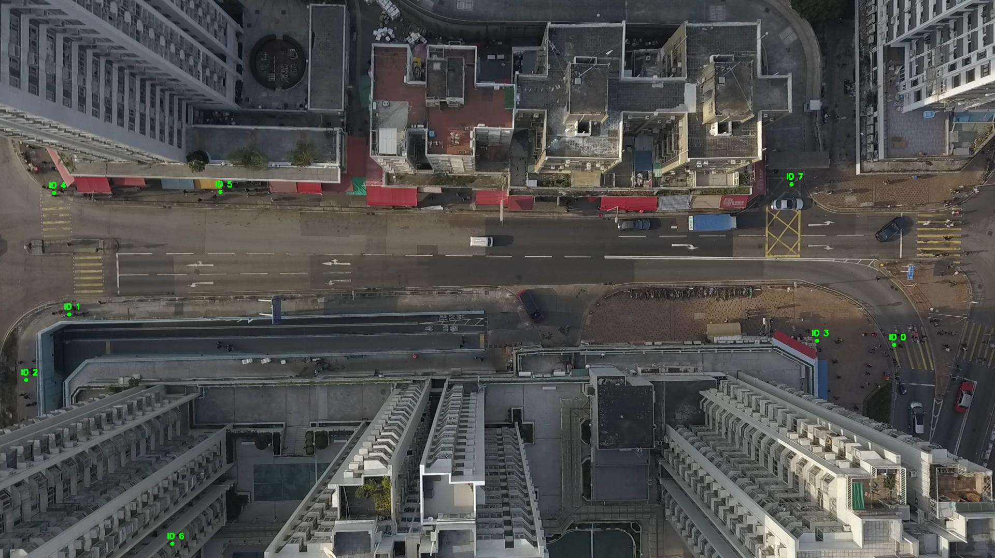

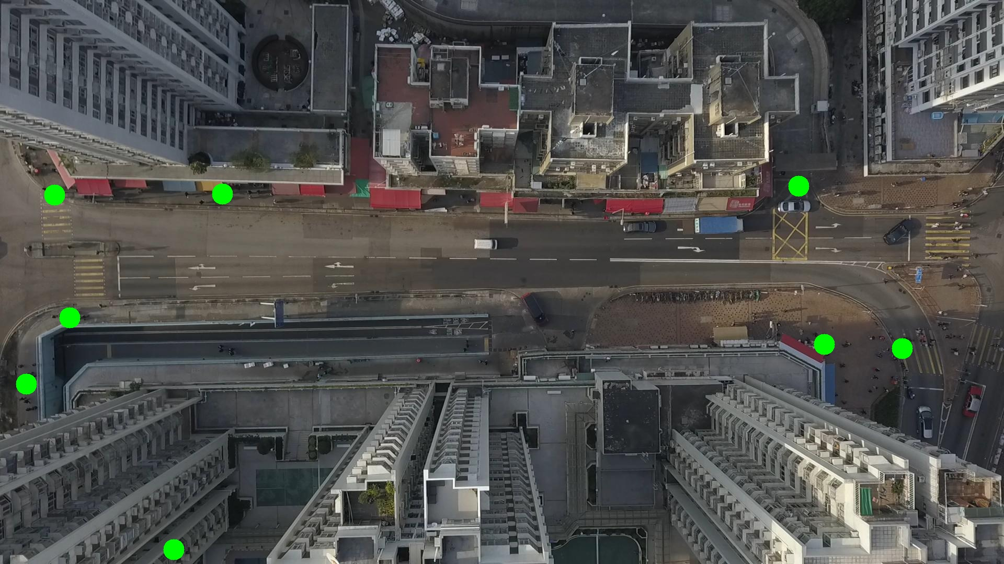

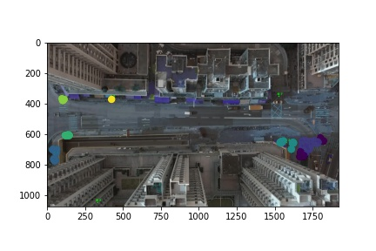

Silhouette metric for img015012.jpg is: 0.6493969477287268

Davies Bouldin metric for img015012.jpg is: 0.3097178588478758

Calinski Harabasz metric for img015012.jpg is: 294419.07942796353

ID 0: (1693, 690)

ID 1: (137, 607)

ID 2: (47, 742)

ID 3: (1580, 658)

ID 4: (101, 372)

ID 5: (426, 371)

ID 6: (331, 1052)

ID 7: (1527, 356)

